## Page:1

# MongoDB Relationships(one-to-one)(one-to-many)(many-to-many)

Step into the captivating world of MongoDB relationships, where data entities intertwine to form a powerful network of connections. In this blog, we embark on an exciting journey to unravel the mysteries of establishing relationships in MongoDB. Discover how MongoDB revolutionizes data organization, querying, and insights, as we explore the seamless power of connections. Join us as we unlock the true potential of data connectivity, reshaping the way we perceive and interact with information.

**Let's Start 💻**

Before diving into MongoDB relationships, let's table two essential concepts: Embedded Documents and Document References:

**Embedded Documents:**

In MongoDB, embedded documents allow us to nest related data within a single document.

Imagine you and your family living in a cozy home. In MongoDB, embedded documents are like each member of your family having their own room within that home. one 👨‍👩‍👧‍👦 one 🏫.

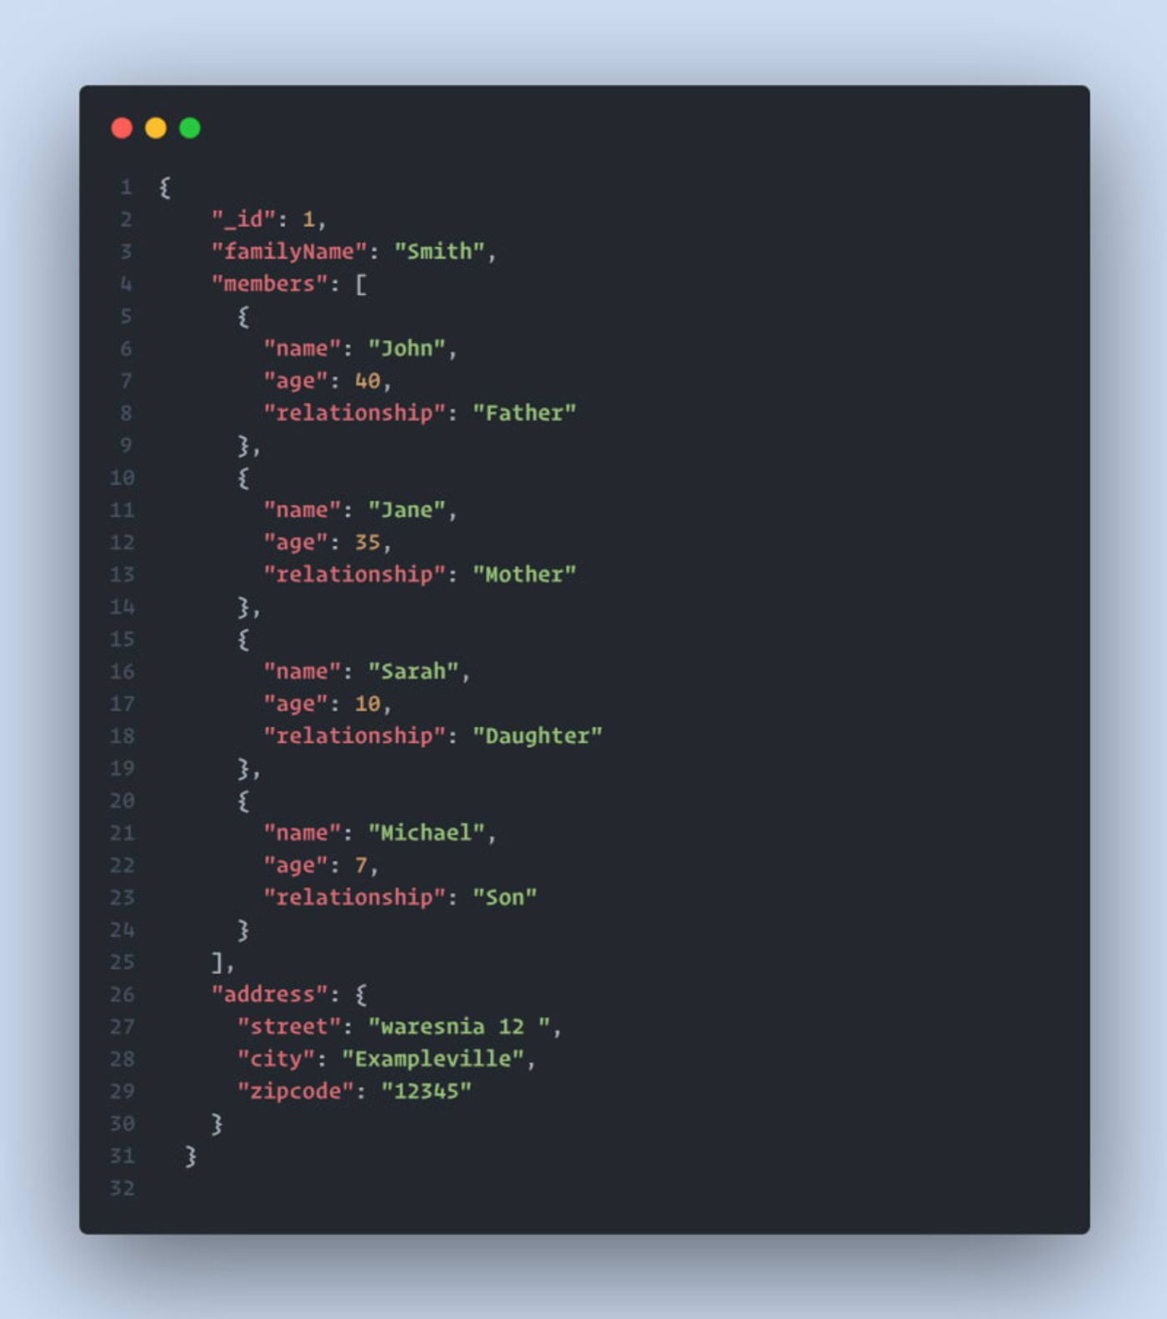

## Page:2

**Document References:**

Document References, on the other hand, establish relationships between documents by referencing one document from another.

Imagine a scenario where you have one family, but each member of this family lives alone in their own separate dwelling. one 👨‍👩‍👧‍👦 but each 👦 alone:

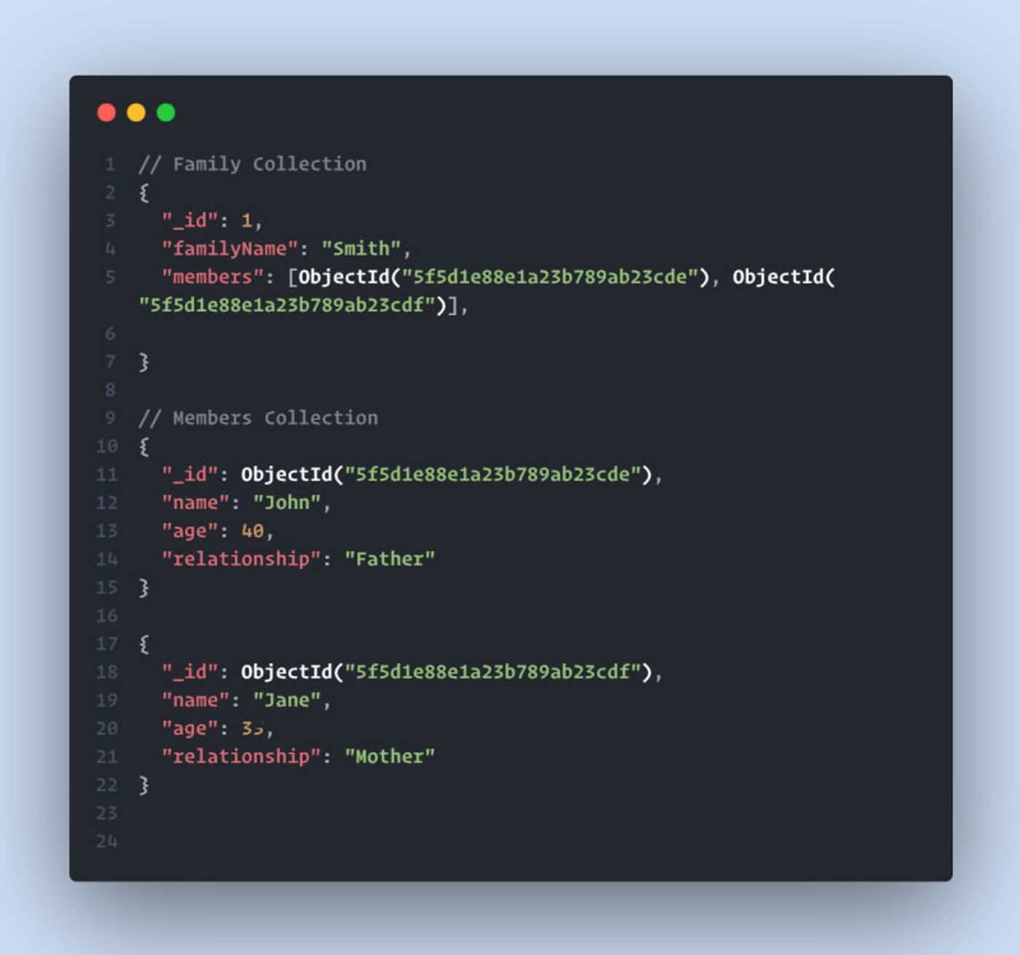**▶️: One-to-one**

let's start with this powerful relation in mongodb:

One-to-one relationships can be likened to the scenario where each individual possesses only one passport.

## Page:3

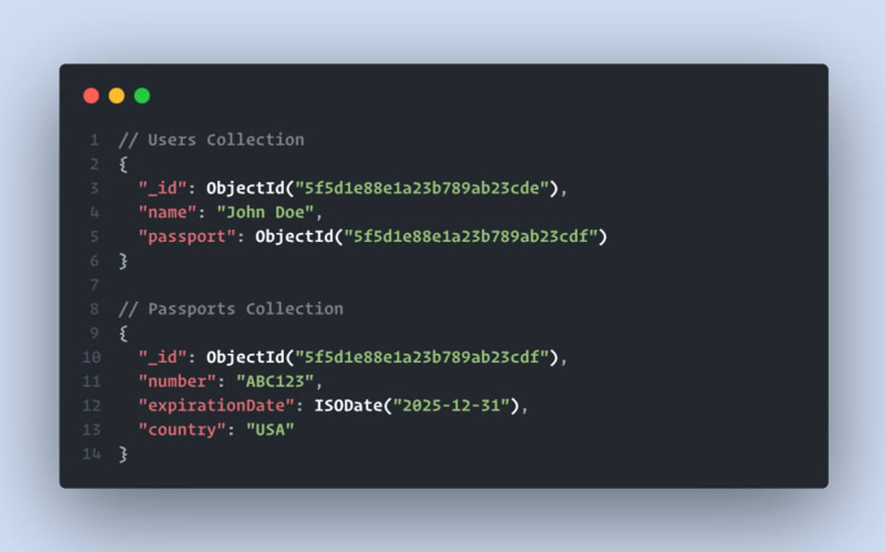

**▶️: One-to-Many**

In a one-to-many relationship, it's similar to the idea that an author can write many books, but each book is written by only one author.

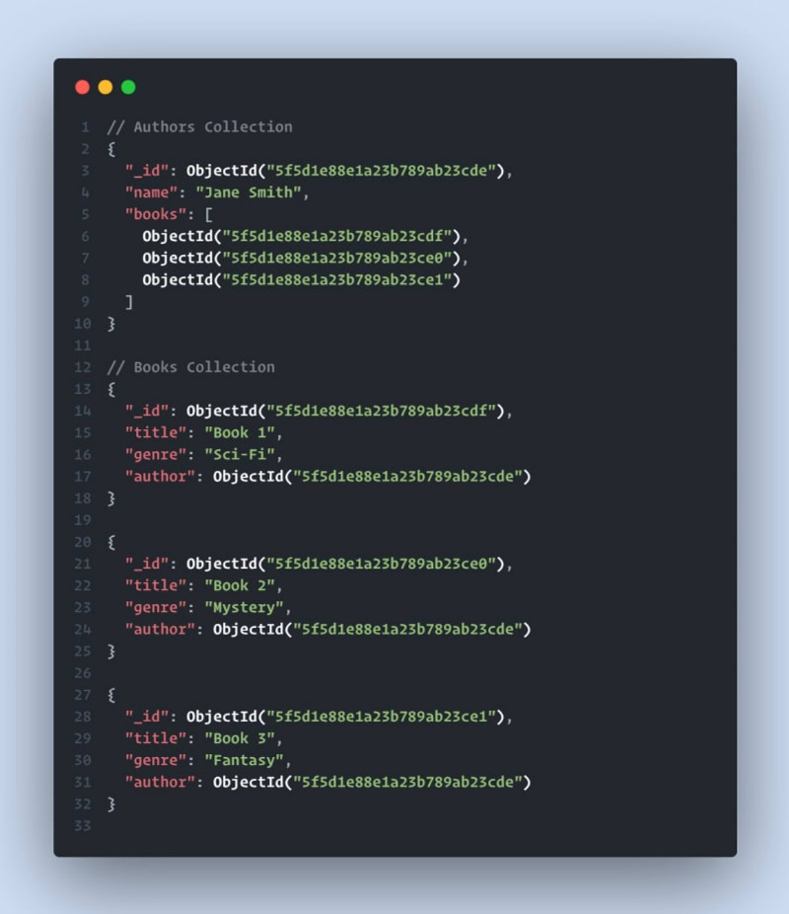

## Page:4

**▶️: Many-to-Many**

In a many-to-many relationship, it's similar to the concept that students can join multiple courses, and each course can be joined by multiple students.

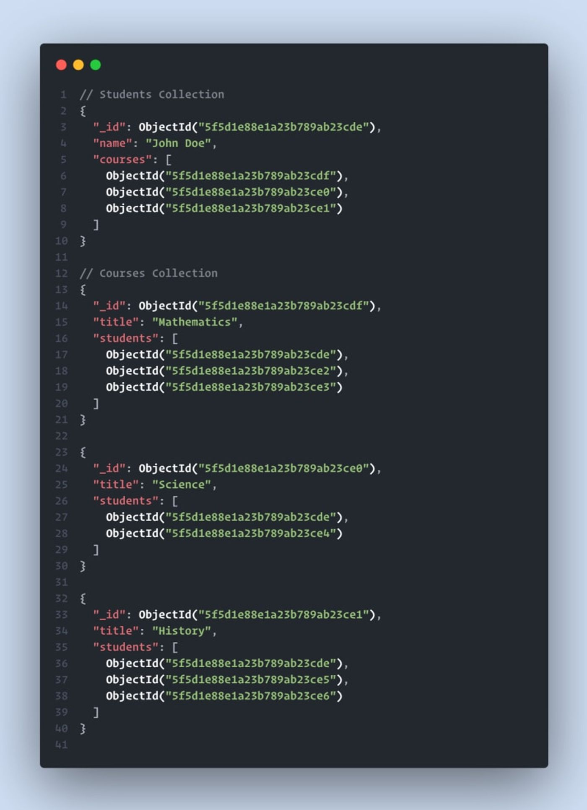

In conclusion, MongoDB offers a wide range of relationship types, including one-to-one, one-to-many, and many-to-many. Developers can choose between embedding and referencing to establish connections between data.

With embedding, related data is stored within a single document, providing a self-contained structure that simplifies queries and improves performance. On the other hand, referencing involves storing references to related documents, allowing for more flexibility and scalability in managing interconnected data.

## Page:5

By leveraging these relationship modeling techniques, developers can design efficient and intuitive database schemas. MongoDB's support for both embedding and referencing empowers developers to optimize data storage, query performance, and data integrity according to their specific application requirements.

Whether you're building applications that require simple or complex relationships, MongoDB provides the necessary tools and flexibility to represent and manage connections between data effectively.